Mesoscopic Simulations of Polyethylene Star Melts by Alexandros Philippas

The target of the present diploma thesis is the characterization of the dynamical, rheological and conformational properties of polyethylene star chains in the melt state. These systems were simulated at a mesoscopic level using the EMSIPON code (Engine for Mesoscopic Simulations of Polymer Networks)^{1–3}. The aforementioned code is designed to carry out Brownian Dynamics simulations of chains consisting of coarse-grained beads. The molecular weights of the chosen systems correspond to the entangled regime of polyethylene. In this model, the topological constraints are represented by slip-springs; dynamic entropic springs which slide along the contours of the chains. The behavior of the slip-springs when approaching the branch point is pivotal for the reproduction of the experimentally observed dynamics. For this reason, two different approaches are tested in this work.^{4,5} Upon creating equilibrated initial configurations, the systems were subjected to equilibrium simulations in the canonical statistical ensemble. From the time evolution of stresses throughout the simulation, the shear relaxation modulus was extracted and, through integration, the zero shear viscosity. From the beads’ trajectories, the mean square displacement of the center of mass of the chains was obtained as a function of time. The self-diffusion coefficient was extracted from long-time slope of the latter (Fickian regime). Furthermore, the mean square displacement with time of the branch points, the mid points and the end points of the arms were extracted. The radius of gyration was also calculated and compared against theoretical prediction. In addition, the shear-viscosity was estimated through non-equilibrium Couette flow simulations, by subjecting the systems to different shear rates and estimating the plateau value the shear stress upon reaching a steady state.
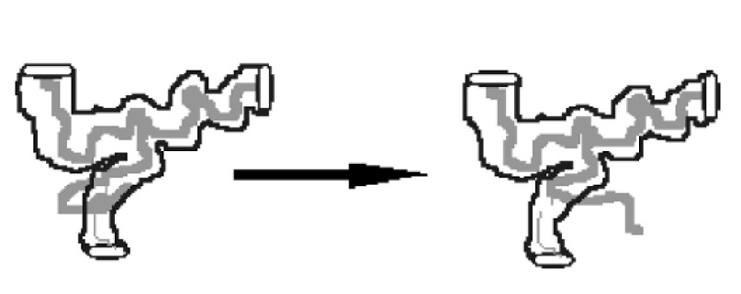
(1) Vogiatzis, G. G.; Megariotis, G.; Theodorou, D. N. Equation of State Based Slip Spring Model for Entangled Polymer Dynamics. Macromolecules 2017, 50 (7), 3004–3029. https://doi.org/10.1021/acs.macromol.6b01705.
(2) Sgouros, A. P.; Megariotis, G.; Theodorou, D. N. Slip-Spring Model for the Linear and Nonlinear Viscoelastic Properties of Molten Polyethylene Derived from Atomistic Simulations. Macromolecules 2017, 50 (11), 4524–4541. https://doi.org/10.1021/acs.macromol.7b00694.
(3) Megariotis, G.; Vogiatzis, G. G.; Sgouros, A. P.; Theodorou, D. N. Slip Spring-Based Mesoscopic Simulations of Polymer Networks : Methodology and The. Polymers (Basel). 2018, No. Md. https://doi.org/10.3390/polym10101156.
(4) Masubuchi, Y. Multichain Slip-Spring Simulations for Branch Polymers. Macromolecules 2018, 51 (24), 10184–10193. https://doi.org/10.1021/acs.macromol.8b01739.
(5) Mcleish, T. C. B. Advances in Physics Tube Theory of Entangled Polymer Dynamics. Adv. Phys. 2002, 51 (6), 1379–1527. https://doi.org/10.1080/00018730210153216.

