Eco-Design of Commodity Polymers for Packaging: Experiments and Computer Simulations

Juan F. Vega

BIOPHYM, Instituto de Estructura de la Materia, IEM-CSIC, 28006 Madrid, Spain
email: jf.vega@csic.es

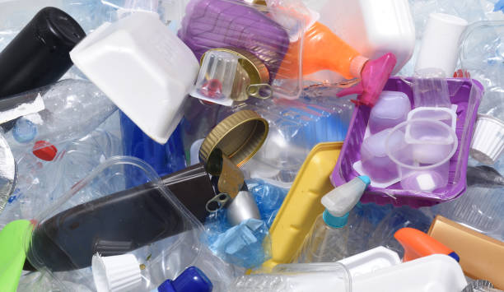
Our research group is interested in the study of mobility and order of polymeric systems, among other research lines. These phenomena range from static and dynamic processes in solution, dilute solution and bulk crystallization, viscoelastic properties in the molten state, and processing, always taking advantage of the synergy between experiments and computer simulations. One of the most challenging issues in Polymer Science today is the fate of plastics. We have decided to make our contribution to solving the recycling problem by focusing our interest on plastics in packaging. Multilayered packaging is one of the most important applications in the world of plastics, but it is also problematic because the different components are not compatible with each other. A common multilayer assembly is made up of polyolefins (structural component), ethylene/vinyl alcohol copolymers (barrier component), and an adhesive or tie layer (usually an ethylene copolymer) [1]. These systems are difficult to recycle because they require a previous separation process (which is both contaminant and expensive) or a mechanical recycling (use of compatibilizers). In this presentation it will be shown how we investigate the interactions between the components in order to find the best design for subsequent mechanical recycling.

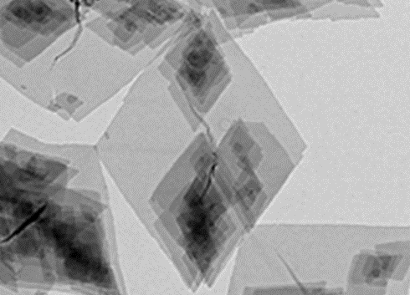
Transmission electron (TEM) and atomic force microscopy (AFM), calorimetry (DSC), infrared spectroscopy (FTIR), linear rheology and computer simulations have all been used to investigate the interactions between the various components of a typical multilayer. The melting point depression Nishi-Wang approach [2] was used to determine the compatibility of the different partners of multilayers. This method requires the presence of at least one crystallizable component. To avoid undesirable effects, single crystals or microcrystal aggregates have been embedded in materials with different functionality (ethylene copolymers), which are commonly used as tie agents in multilayers. First, the morphological aspects of the single crystals and aggregates have been evaluated. Second, the compatibility of all tie agents with the structural and barrier components have been assessed, in order to define the most effective system for a subsequent compatibilization during the recycling step. Finally, selected blends prepared to ensure interactions at the segment level have been studied by melt rheology. It will be seen that the polyolefin component will play a crucial and limiting role. The results indicate that the molecular architecture of these materials is of key importance and will be critical to the eco-design of multilayer systems when it comes to obtaining mechanically recyclable systems [3,4].

References

[1] J.K. Kim, Multicomponent Polymeric Materials, Sabu Thomas Prosenjit Saha Editors, Springer Series in Materials Science 2016, Vol. 223.
[2] T. Nishi and T.T. Wang. Macromolecules 1975, 8, 909.
[3] J.F. Vega, V. Souza-Egipsy, M.T. Expósito and J. Ramos, Polymers 2022, 14(8).
[4] J.F. Vega, V. Souza-Egipsy, J. Ramos and J. Martínez-Salazar, Polymer 2022, 125256.

